zion PREVENTION times
November 2019

iMPORTANT INFORMATION From:
Dawn Walton Substance Abuse Prevention Specialist
Serving Areas 12 & 13

Email: dwalton@zionrecovery.org
Find more information: www.zionrecovery.org
Like us on Facebook: Zion Recovery Services Prevention Department
HOLIDAYS:
Daylight Saving’s Time End’s - November 3 Veteran’s Day - November 11 Thanksgiving Day - November 28 Black Friday - November 29

ZION RECOVERY SERVICES WILL BE CLOSED ON MONDAY 11/11 and THURSDAY 11/28

Month Happenings:
Lung Cancer Awareness Month Great American Smoke out November 21 International Survivors of Suicide Loss Day November 23 International Day for the Elimination of Violence against Women November 25

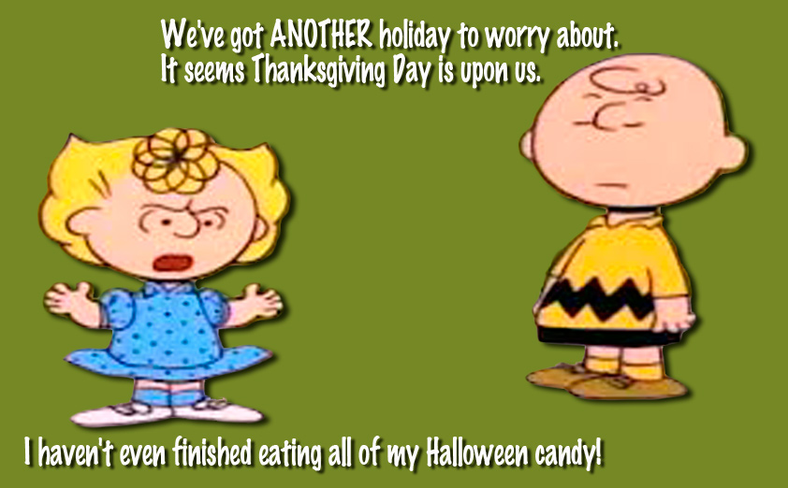

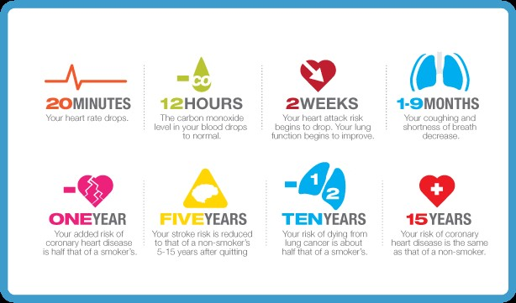
Lung cancer kills
Almost 2x as many women as breast
cancer. The #1 Cancer
Lady Killer since 1987

Every 3.3 minutes
someone in the U.S.
dies of lung cancer.
Less time than it takes
to sing Breathless (3:42 min).

Lung cancer kills
433 Americans every day.
That’s the same number of seats on a 747.

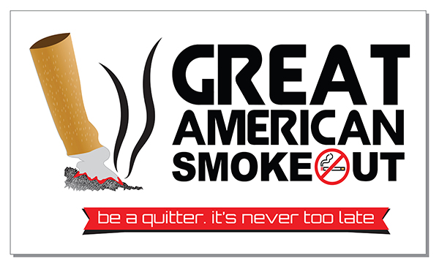
What is the Great American Smokeout?
For more than 40 years, the American Cancer Society has hosted the Great American Smokeout on the third Thursday of November. The Great American Smokeout is an opportunity for people who smoke to commit to healthy, smoke -free lives – not just for a day, but year-round. The Great American Smokeout provides an opportunity for individuals, community groups, businesses, health care providers, and others to encourage people to use the date to make a plan to quit, or plan in advance and initiate a smoking cessation plan on the day of the event. The Great American Smokeout event challenges people to stop smoking and helps people learn about the many tools they can use to help them quit and stay quit.
It's hard to quit tobacco
Addiction to nicotine in cigarettes is one of the strongest and most deadly addictions one can have. Quitting is hard for many people who smoke. It takes commitment and starts with a plan, often takes more than one quit attempt, and requires a lot of support. Often, the younger one was when he or she started to smoke, the more intense the addiction.

People who smoke are strongly advised to use proven cessation methods, such as prescription medications and counseling, to quit smoking. It’s a good idea to talk to your doctor or pharmacist to get their advice.

Research shows that people who smoke are most successful in their efforts to stop smoking when they have support, such as:
- Telephone quit lines
- American Cancer Society Freshstart Program
- Nicotine Anonymous meetings
- Self-help books and materials
- Smoking counselors or coaches
- Encouragement and support from friends and family members
Using 2 or more of these measures to quit smoking works better than using any one of them alone. For example, some people use a prescription medicine along with nicotine replacement. Other people may use as many as 3 or 4 of the methods listed above. Professional guidance can help you choose the approach that’s right for you.

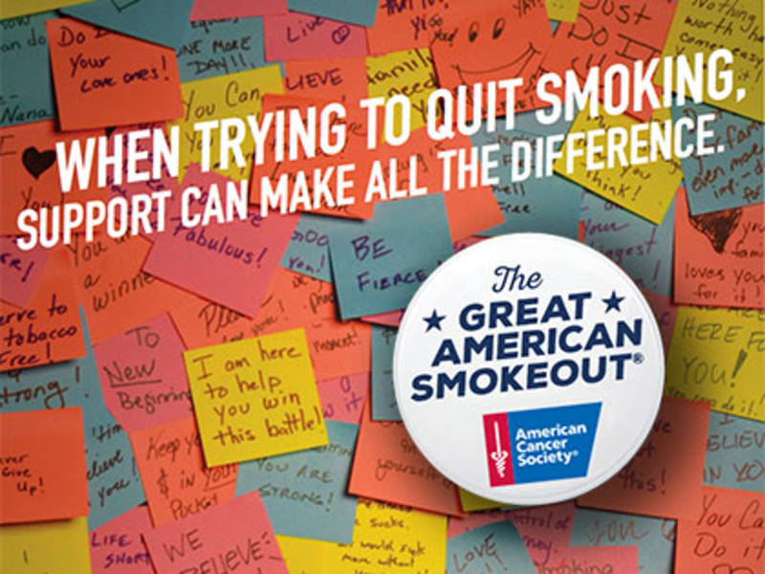

While cigarette smoking rates have dropped, about 37.8 million Americans smoke cigarettes. About half of all Americans who keep smoking will die because of their smoking. Each year more than 480,000 people in the United States die from illnesses caused by smoking. This means each year smoking causes about 1 out of 5 deaths in the US

Cigarette smoking is the leading cause of cancer death in the United States, accounting for 29% of all cancer deaths. Lung cancer is the leading cause of cancer death for men and women. Smoking also causes cancers of the larynx (voice box), mouth, sinuses, pharynx (throat), esophagus (swallowing tube), and bladder. It also has been linked to the development of cancers of the pancreas, cervix, ovary (mucinous), colon/rectum, kidney, stomach, and some types of leukemia. Cigars and pipes cause cancers, too.

Helping a Smoker Quit: Do’s and Don’ts
General hints for friends and family
Do respect that the quitter is in charge. This is their lifestyle change and their challenge, not yours. Do ask the person whether they want you to ask regularly how they’re doing. Ask how they’re feeling – not just whether they’ve stayed quit. Do let the person know that it’s OK to talk to you whenever they need to hear encouraging words. Do help the quitter get what they need, such as hard candy to suck on, straws to chew on, and fresh veggies cut up and kept in the refrigerator. Do spend time doing things with the quitter to keep their mind off smoking – go to the movies, take a walk to get past a craving (what many call a “nicotine fit”), or take a bike ride together. Do try to see it from the smoker’s point of view – a smoker’s habit may feel like an old friend that’s always been there when times were tough. It’s hard to give that up. Do make your home smoke free, meaning that no one can smoke in any part of the house. Do remove all lighters and ash trays from your home. Remove anything that reminds them of smoking. Do wash clothes that smell like smoke. Clean carpets and drapes. Use air fresheners to help get rid of the tobacco smells – and don’t forget the car, too. Do help the quitter with a few chores, some child care, cooking – whatever will help lighten the stress of quitting. Do celebrate along the way. Quitting smoking is a BIG DEAL!

Don’t doubt the smoker’s ability to quit. Your faith in them reminds them they can do it.
Don’t judge, nag, preach, tease, or scold. This may make the smoker feel worse about him or herself. You don’t want your loved one to turn to a cigarette to soothe hurt feelings.
Don’t take the quitter’s grumpiness personally during their nicotine withdrawal. Tell them that you understand the symptoms are real and remind them that they won’t last forever. The symptoms usually get better in about 2 weeks.
Don’t offer advice. Just ask how you can help with the plan or program they are using.

If your ex-smoker “slips”
Don’t assume that they will start back smoking like before. A “slip” (taking a puff or smoking a cigarette or 2) is common when a person is quitting.
Do remind the quitter how long they went without a cigarette before the slip.
Do help the quitter remember all the reasons they wanted to quit and help them forget about the slip as soon as possible.
Do continue to offer support and encouragement. Remind them they’re still a “quitter” – NOT a smoker.
Don’t scold, tease, nag, blame, or make the quitter feel guilty. Be sure the quitter knows that you care about them whether or not they smoke.

If your quitter relapses
Research shows that most people try to quit smoking several times before they succeed. (It’s called a relapse when smokers go back to smoking like they were before they tried to quit.) If a relapse happens, think of it as practice for the next time. Don’t give up your efforts to encourage and support your loved one. If the person you care about fails to quit or starts smoking again:

Do praise them for trying to quit, and for whatever length of time (days, weeks, or months) of not smoking. Do remind your loved one that they didn’t fail – they are learning how to quit – and you’re going to be there for them the next time and as many times as it takes.
Do encourage them to try again. Don’t say, “If you try again...” Say, “When you try again...” Studies show that most people who don’t succeed in quitting are ready to try again in the future. Do encourage them to learn from the attempt. Things a person learns from a failed attempt to quit may help them quit for good next time. It takes time and skills to learn to be a non-smoker. Do say, “It’s normal to not succeed the first few times you try to quit. Most people understand this and know that they have to try to quit again. You didn’t smoke for (length of time) this time. Now you know you can do that much. You can get even further next time.”

If you are a smoker
Do smoke outside and always away from the quitter.
Do keep your cigarettes, lighters, and matches out of sight. They might be triggers for your loved one to smoke.
Don’t ever offer the quitter a smoke or any other form of tobacco, even as a joke!
Do join your loved one in their effort to quit. It’s better for your health and might be easier to do with someone else who is trying to quit, too.

MORE INFORMATION ON THE GREAT AMERICAN SMOKE OUT

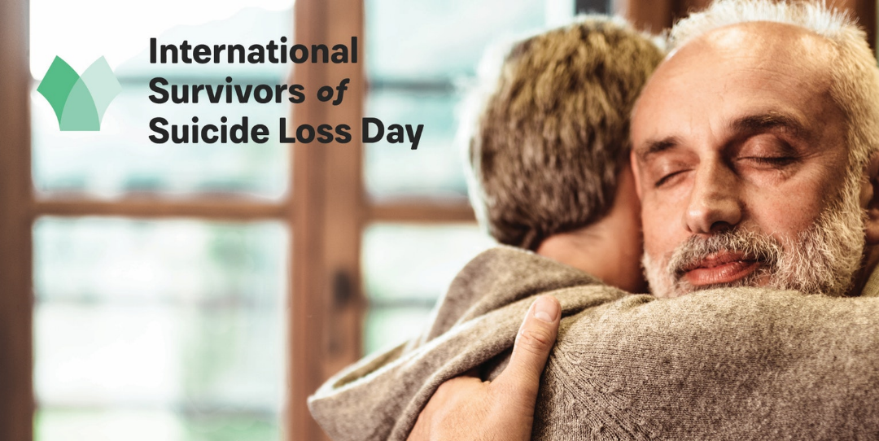
International Survivors of Suicide Loss Day is November 23, 2019.

In 1999, Senator Harry Reid, who lost his father to suicide, introduced a resolution to the United States Senate which led to the creation of International Survivors of Suicide Loss Day. Also known as Survivor Day, the day was designated by the United States Congress as a day on which those affected by suicide can join together for healing and support. It was determined that Survivor Day would always fall on the Saturday before American Thanksgiving, as the holidays are often a difficult time for suicide loss survivors.

In 2018, 370 total events took place, including 32 international sites in 19 countries.

CLICK HERE TO FIND AN EVENT NEAR YOU

VISIT: www.afsp.org for more information

Why we must eliminate violence against women
Violence against women and girls (VAWG) is one of the most widespread, persistent and devastating human rights violations in our world today remains largely unreported due to the impunity, silence, stigma and shame surrounding it.
Every woman has the right to live her life safely and free of violence.
Yet one in four women in the United States experiences violence from an intimate partner. Intimate partner violence includes domestic abuse, sexual assault, verbal and emotional abuse, coercion, and stalking. Violence and abuse can cause physical and emotional problems that last long after the abuse.

What are the challenges to ending violence against women?
Ending violence against women and girls is an effort that includes everyone in our society. Violence is a violation of a basic human right for safety. Violence against women has been happening for a long time, but we can work together to prevent it in the future.

Violence against women can be prevented by strengthening women’s access to basic human rights and resources. Research shows that communities with more access to education, jobs, housing, health care, affordable child care and elder care, and equality for both men and women have lower rates of violence against women.

What are the challenges to ending sexual violence against women?
In addition to challenges in ending all violence against women, ending sexual violence against women requires more gender equality in all parts of society. Part of being human is our sexuality. Sex and gender influence many different parts of a person’s life. Sexual violence against women can happen when a woman’s value in society is seen only through her sexuality. When women are not seen as equals to men, they are more likely to be victimized through their sexuality.

Women who have experienced sexual assault are often blamed for the assault. Blaming a woman for another person’s choice to assault her is wrong. Many women who report sexual assault are asked questions about what they were wearing, whether they were drinking or using drugs, or where they were during the assault. These questions imply that the sexual assault was the victim’s fault. Sexual assault is always the responsibility of the person who committed the assault. It is never the victim’s fault.

In order to end sexual violence against women, we must agree as a society that sexual contact between people cannot happen unless there is clear consent.

MORE INFORMATION ON VIOLENCE AGAINST WOMEN

MORE INFORMATION ON INTERNATIONAL DAY FOR
THE ELIMINATION OF VIOLENCE AGAINST WOMEN
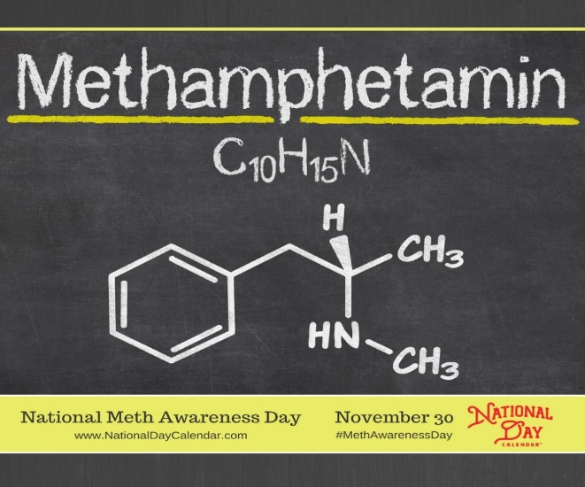

NATIONAL METH AWARENESS DAY
November 30 has been declared National Methamphetamine Awareness Day as a part of a nationwide effort to further educate the American public about the effects of methamphetamine abuse on families and communities. The initiative hopes to increase awareness and decrease demand for the highly-addictive drug.

METHAMPHETAMINE FACTS
- Methamphetamine is usually a white, bitter-tasting powder or a pill. Crystal methamphetamine looks like glass fragments or shiny, bluish-white rocks.
- Methamphetamine is a stimulant drug that is chemically like amphetamine (a drug used to treat ADHD and narcolepsy).
- People can take methamphetamine by smoking, swallowing, snorting, or injecting the drug.
- Methamphetamine increases the amount of dopamine in the brain, which is involved in movement, motivation, and reinforcement of rewarding behaviors.
- Short-term health effects include increased wakefulness and physical activity, decreased appetite, and increased blood pressure and body temperature.
- Long-term health effects include risk of addiction; risk of contracting HIV and hepatitis; severe dental problems ("meth mouth"); intense itching, leading to skin sores from scratching; violent behavior; and paranoia.
- Methamphetamine can be highly addictive. When people stop taking it, withdrawal symptoms can include anxiety, fatigue, severe depression, psychosis, and intense drug cravings.
- Researchers don't yet know if people breathing in secondhand methamphetamine smoke can get high or suffer other health effects.
- A person can overdose on methamphetamine. Because methamphetamine overdose often leads to a stroke, heart attack, or organ problems, first responders and emergency room doctors try to treat the overdose by treating these conditions.

Know the Risks of Meth
Methamphetamine (meth) is a powerful, highly addictive drug that causes devastating health effects, and sometimes death, even on the first try.
Meth is easy to get addicted to and hard to recover from. Meth is a dangerous, synthetic, stimulant drug often used in combination with other substances that can be smoked, injected, snorted, or taken orally. Someone using meth may experience a temporary sense of heightened euphoria, alertness, and energy. But using meth changes how the brain works and speeds up the body’s systems to dangerous, and sometimes lethal, levels—increasing heart rate, blood pressure, body temperature, and respiratory rate. Chronic meth users also experience anxiety, confusion, insomnia, paranoia, aggression, visual and auditory hallucinations, mood disturbances, and delusions.

The Rise of Meth Use in the United States
The number of fatal overdoses involving meth has more than tripled between 2011 and 2016, according to the CDC. Use is also on the rise between 2016-2018 for most age groups. In 2018, more than 106,000 adults aged 26 or older used meth—a 43 percent increase over the previous year.

Short-term Effects of Meth
Even taking small amounts of meth, or just trying it once, can cause harmful health effects, including:
- Increased blood pressure and body temperature
- Faster breathing
- Rapid or irregular heartbeat
- Loss of appetite, disturbed sleep patterns, or nausea
- Bizarre, erratic, aggressive, irritable, or violent behavior

Long-term Health Risks of Meth
Chronic meth use leads to many damaging, long-term health effects, even when users stop taking meth, including:
- Permanent damage to the heart and brain
- High blood pressure leading to heart attacks, strokes, and death
- Liver, kidney, and lung damage
- Anxiety, confusion, or insomnia
- Paranoia, hallucinations, mood disturbances, delusions, or violent behavior (psychotic symptoms can sometimes last for months or years after quitting meth)
- Intense itching, causing skin sores from scratching
- Severe dental problems (“meth mouth”)

CLICK THE PICTURE FOR MORE INFORMATION

Phases of Gambling
There are three distinct stages people with gambling problems go through before they "hit bottom" and realize they need help.

Winning
Gambling begins as a social activity. It seems fun, normal. During this phase, people:
- Sometimes win large amounts of money
- Feel invincible, so they bet bigger amounts
- Bet even more to maintain the excitement level
But gambling isn't always about money. Problem gamblers like the excitement of gambling, the dream of winning big, or the escape from everyday problems or stresses.

Losing
This is where the real trouble begins. Gamblers feel like their activity is under control, but, it’s not. During this phase, people:
- Seek more action
- Believe they can quit whenever they want to – but see no need to quit
- Gamble to win back what they've lost
- Gamble and then lie about it
- Hide their losses
- Take out loans so they can continue
- Break their promises to quit
- Borrow from family and friends
- Have relationships that begin to suffer

Desperation
Problem gamblers go through this state just before they hit rock bottom. During this phase, people:
- Feel desperation and hopelessness as losses continue to mount
- Cling to their fantasy of winning -- hoping to make everything well again
- Finally realize that they can't win, but they keep gambling anyway
- Have little concern for the people around them
- Steal, write bad checks, or commit illegal activities to finance their gambling
Some problem gamblers attempt suicide before they seek treatment.

Problem gamblers come from many backgrounds. They can be rich or poor, young or old, male or female. Problem gambling can affect people of every race, every religion, and every education and income level. It happens in small towns or big cities.

