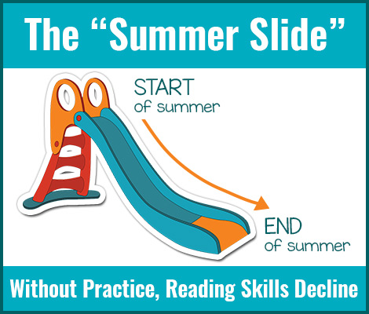
What Is the Summer Slide?
The summer slide is a decline in reading ability and other academic skills that can occur over the summer months when school isn’t in session.
Studies show that kids who don’t read during summer vacation actually slip in reading ability by the time fall rolls around.
But as parents, we don’t need studies to tell us this, do we? It’s evident in all sorts of situations. For example, if your child plays the piano but stops practicing for three months, his skills will decline more than the skills of a child who continued to practice and play the piano over the summer, right? So what can we do to avoid this common problem?

How to Prevent the Summer Slide
Here’s the secret to preventing the summer slide: Keep learning all summer long! (Now, don’t panic, I’m not talking about year-round schooling.) I’m talking about providing learning opportunities throughout the summer to keep kids’ academic skills sharp. Check out the attached flyer for a list of ideas to help you put an end to the summer slide!

